1. Fdop=f(v/c)cos(Θ); $\sqrt{\frac{MG}{(R+h)}}$

Satellite travels 7503 m/s at 7km above the earths surface

* 1. 31,263.45 Hz @0 degrees
  2. 0 Hz @90 Degrees
  3. 22106 Hz @45 Degrees
  4. The direction that would be least sensitive to a speeding driver would be 90 degrees, this is because the doppler effect is not in action at this angle, the reading would not say any speed difference

1. 1. 333,060.4 earths would match the mass of the sun
   2. The orbital velocity of the earth is 29980.11 m/s
   3. From the values found in previous question, it would take the earth 358 days orbit the sun, compared to the actual value of 365.25, it is not far off but would probably mean that we would need a much different leap year system
2. 1. R21water = 4/7 = .571 ; R21veg = 13/13 = 1 ; R21soil = 17/23 = .739
   2. R51water = 0/7 = 0 ; R51veg = 35/13 = 2.692 ; R51soil = 50/23 = 2.173
   3. R21water and R21veg has a small percent difference, only having a .2 difference from one another. R51water and R51veg has a huge difference because R5water has no reflectivity while R1water has some, so the ratio is 0, while R51veg has a pretty big ratio as the reflectivity of R5veg is a lot higher than that of R1veg, the image with most contrast from water to vegetation would be R51 because the values of the ratio are a lot further from each other.
3. 1. 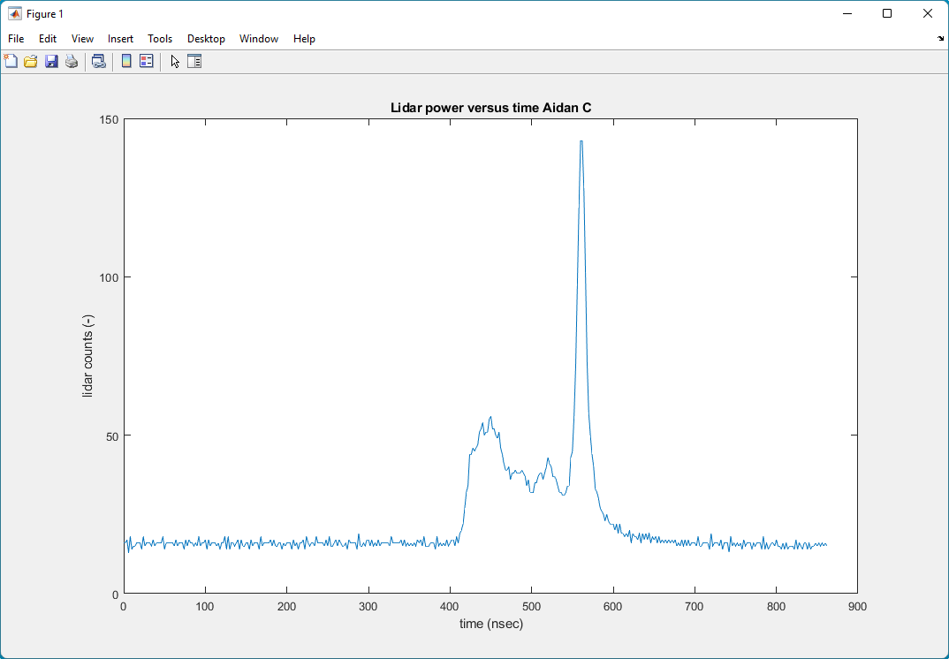

|  |  |  |  |  |
| --- | --- | --- | --- | --- |
| Top of Canopy time  (nsec) | Ground return time (nsec) | Time difference (nsec) | Round-trip difference (m) | Height of trees (m) |
| 424 | 560 | 136 | 40.8 | 20.4 |

* 1. 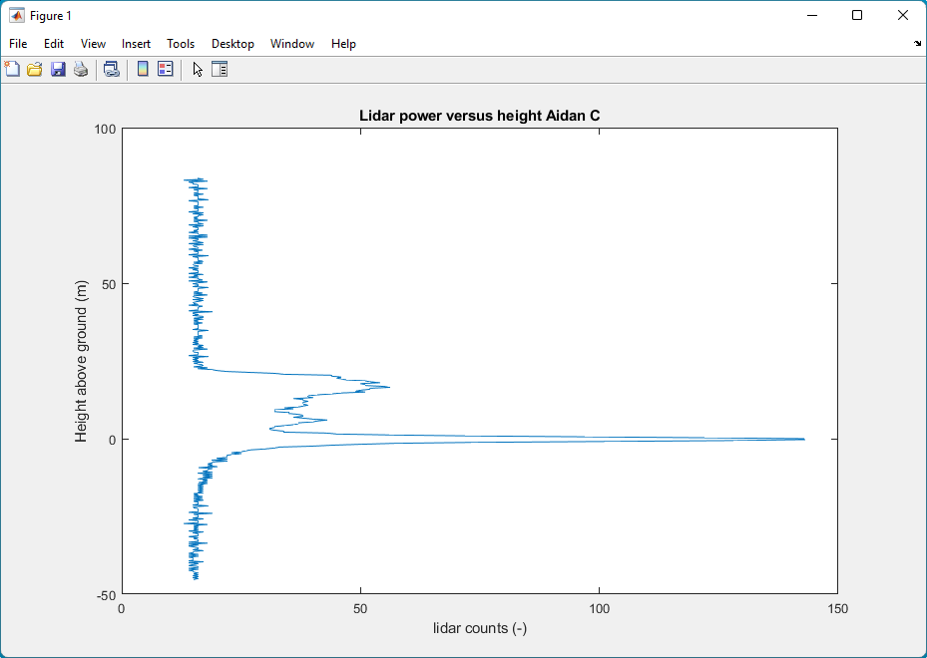

1. 1. 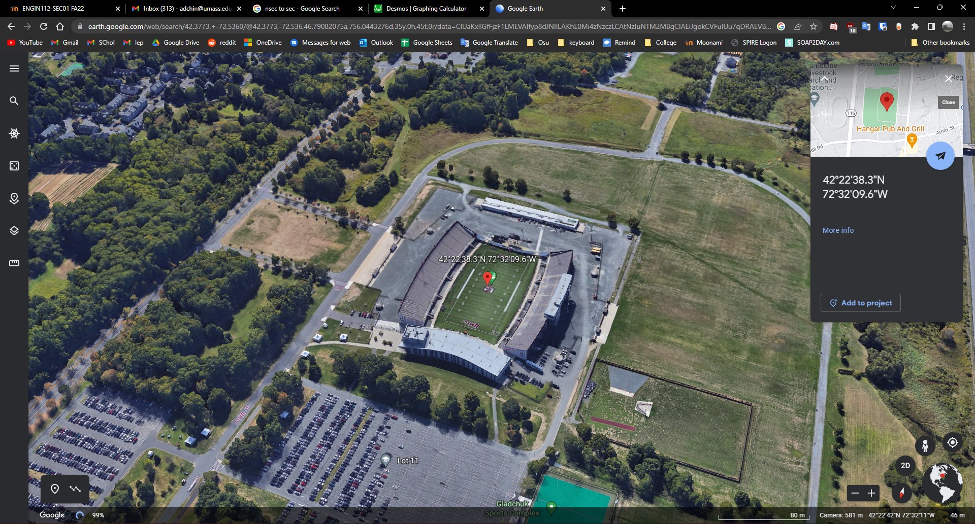

|  |  |
| --- | --- |
| Latitude (deg) | Longitude (deg) |
| 42.6917 | -72.1382 |

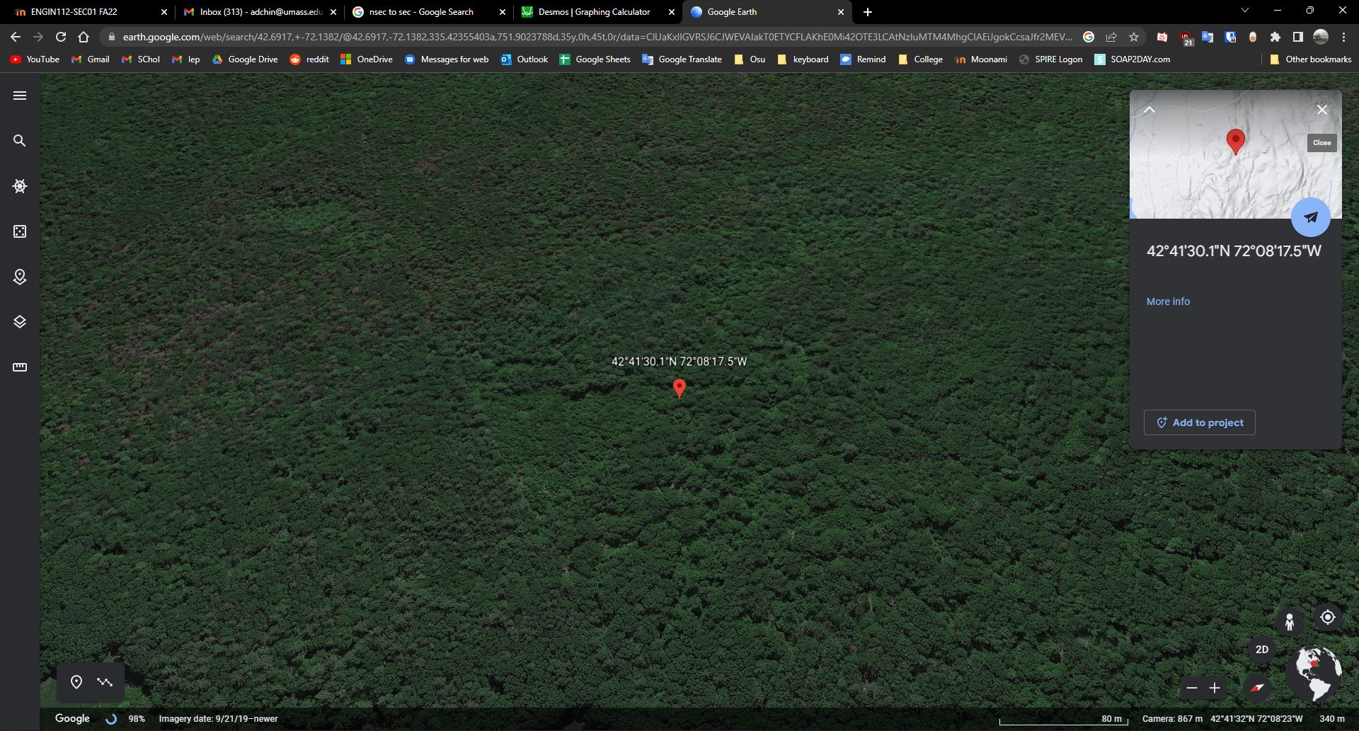

1. 1. 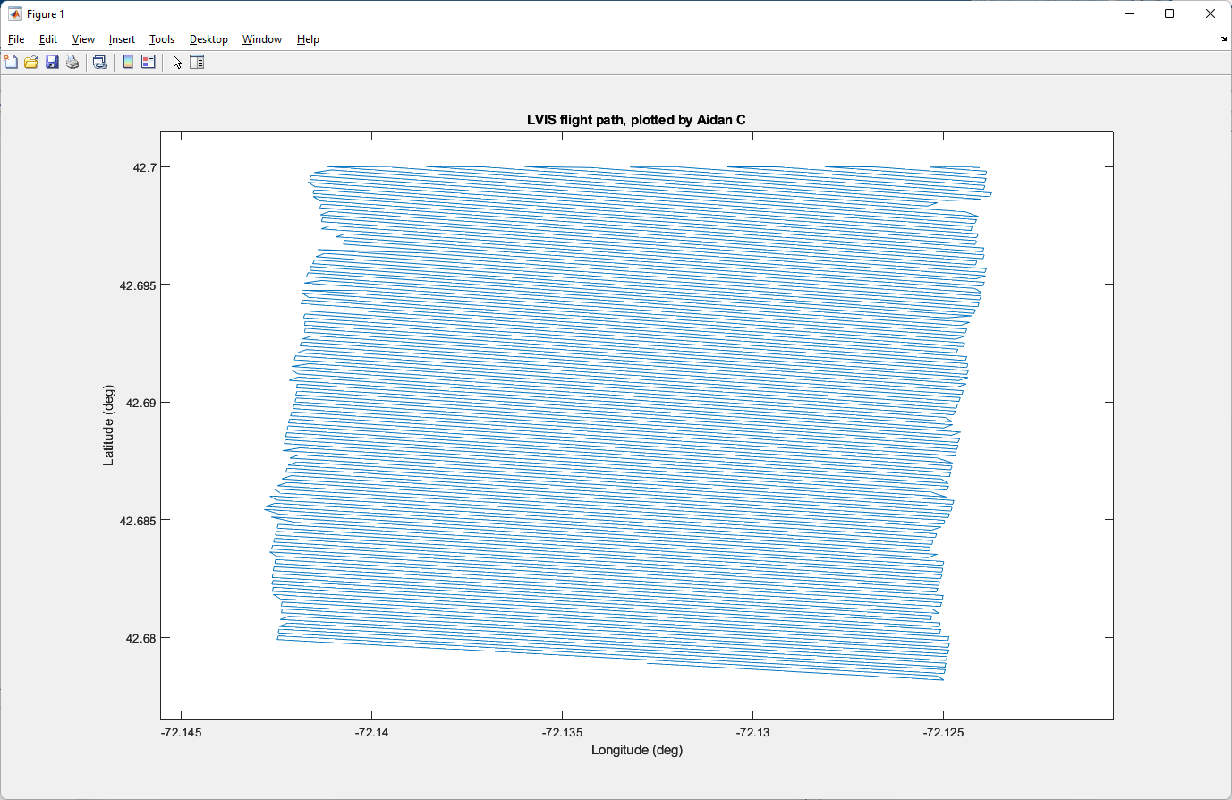
   2. 2.25 km length

1.47 km width

